**Exercise 5-1 CGAN**

Jirayu Petchhan, D10907801

**As the default setting**

Hyper parameter, criterion and network structure

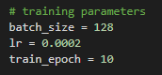

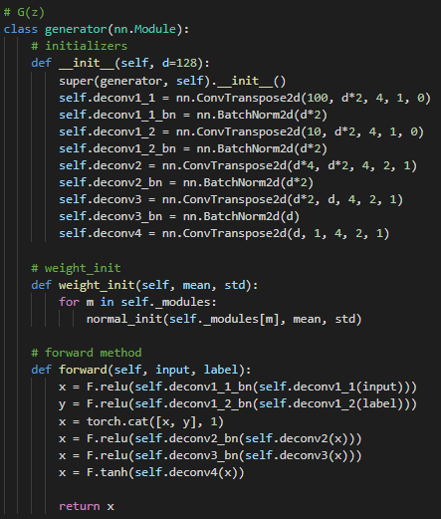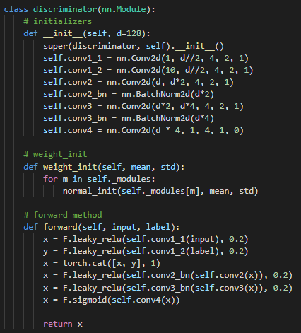

The result

Training iteration (10 epochs)

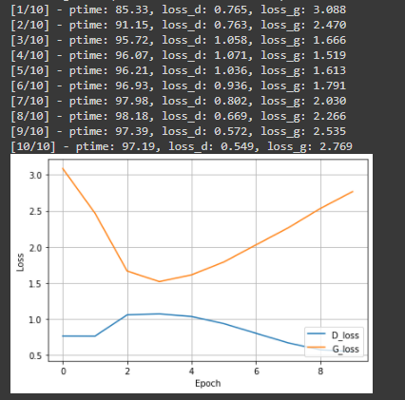

Generated image according to condition (via one-hot labels) i.e., following as 0 to 9.

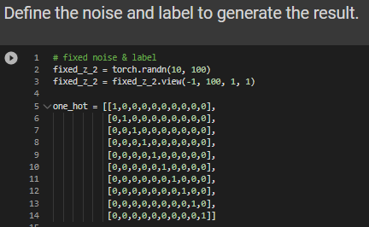

Generated synthetic images according to defined specified labels

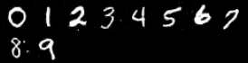

0933265621

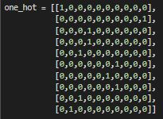

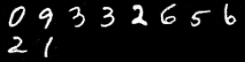

Training at 10th epoch time.

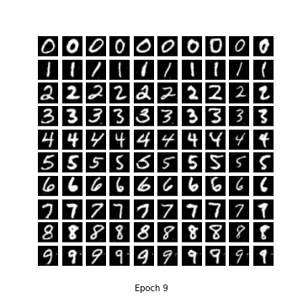

**Conclusion**

As we tested to train the Conditional GANs, we got the error wasn’t improved as well. Probably owing to the amount of training iteration and epochs is a little, or the model is not deep as far as enough. Nevertheless, we knew the training setup and the procedure for training in conditional GAN between G and D network and Generator had established the synthetic images in test phase that rely on one-hot labels as user required.